**1. Write an algorithm, draw a flowchart and Write a PHP script to print the value of variable in PHP and use print function for printing.**

<!DOCTYPE html>

<html>

<head>

<title>Print</title>

</head>

<body>

<?php

$txt1="Welcome to PHP";

$txt2="www.tppl.org.in";

$x=15;

$y=4;

print"<h2>$txt1</h2>";

print"Study PHP at $txt2<br>";

print$x+$y;

?>

</body>

</html>

**Output:-**

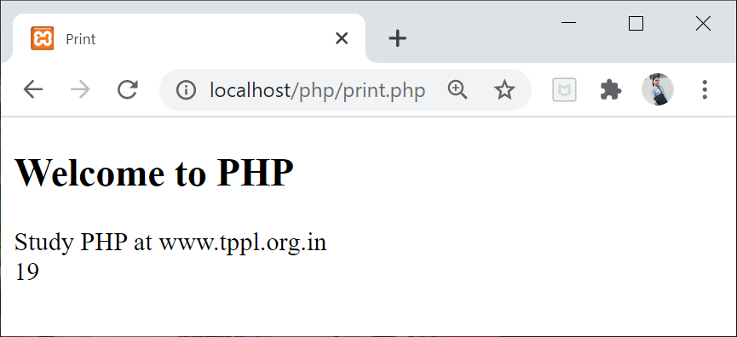

**2. Write an algorithm, draw a flowchart and Write a PHP script to print the values of variable using echo.**

<!DOCTYPE html>

<html>

<head>

<title>echo</title>

</head>

<body>

<?php

$numbers =233;

echo "What is full form of PHP:<br>";

echo 'Hypertext Preprocessor<br>';

echo $numbers;

?>

</body>

</html>

**Output:-**

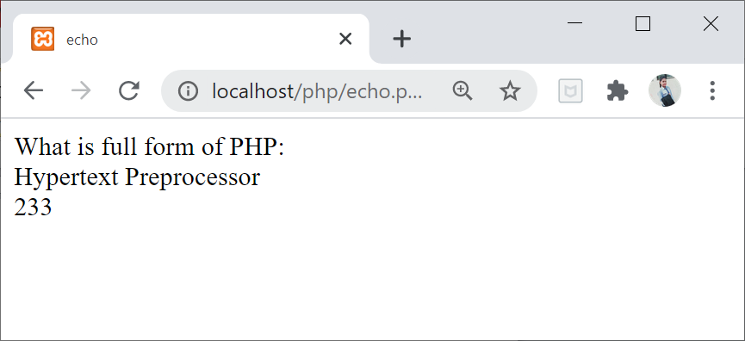

**3.Write an algorithm, draw a flowchart and Write a PHP script to print the following pattern using nested loop.**

*  
**  
***  
****  
*****

<!DOCTYPE html>

<html>

<head>

<title> </title>

</head>

<body>

<?php

for ($i=1; $i<=5; $i++)

{

for ($j=1; $j<=$i; $j++)

{

echo "*";

}

echo "<br/>";

}

?>

</body>

</html>

**Output:-**

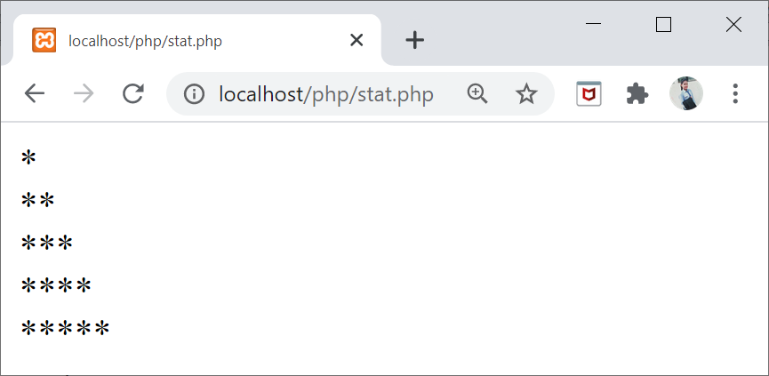

**4. Write an algorithm, draw a flowchart and Write a PHP script to that creates the following table using for loops. Add cellpadding=”3px” and cellspacing=”0px”to table tag.**

<!DOCTYPE html>

<html>

<head>

<title>table</title>

</head>

<body>

<table align="left" border="1px" cellpadding="3px" cellspacing="0px">

<?php

for($i=1;$i<=6;$i++)

{

echo "<tr>";

for ($j=1;$j<=5;$j++)

{

echo"<td>$i*$j=".$i*$j."</td>";

}

echo "</tr>";

}

?>

</body>

</html>

**Output:-**

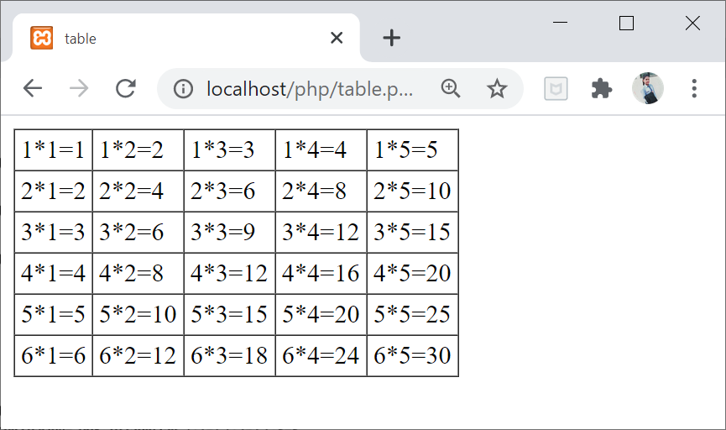

**5.Write an algorithm, draw a flowchart and Write a PHP script to insert a new item in an array on any position.**

<!DOCTYPE html>

<html>

<head>

<title></title>

</head>

<body>

<?php

$original = array('1','2','3','4','5');

echo 'Original array :'."<br/>";

foreach ($original as $x)

{

echo "$x";

}

$inserted ='$';

array_splice($original,3,0,$inserted);

echo "<br/>After inserting '$' the array is :<br/>"."\n";

foreach($original as $x)

{

echo "$x";

}

echo "\n";

?>

</body>

</html>

**Output:**

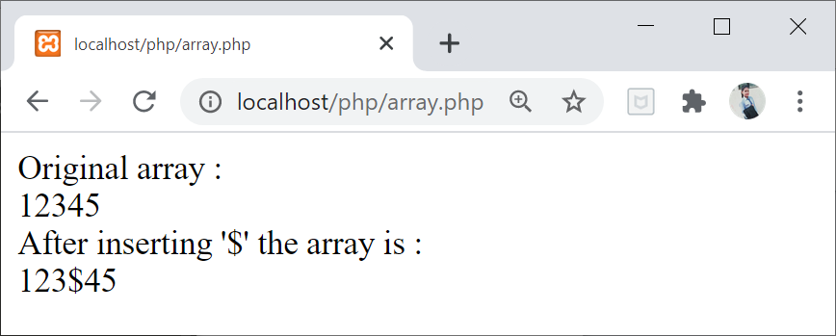

**6. Write an algorithm, draw a flowchart and Write a PHP script to sort an array of positive integer using the sort function asort() and ksort().**

<!DOCTYPE html>

<html>

<head>

<title></title>

</head>

<body>

<?php

// Define array

$age = array("Peter"=>20, "Harry"=>14, "John"=>45, "Clark"=>35);

// Sorting array by value and print

asort($age);

echo"asorting array :-";

//sorting by number its key

print_r($age);

ksort($age);

echo"ksorting array :-";

//sorting by string its defines

print_r($age);

?>

</body>

</html>

**Output:**

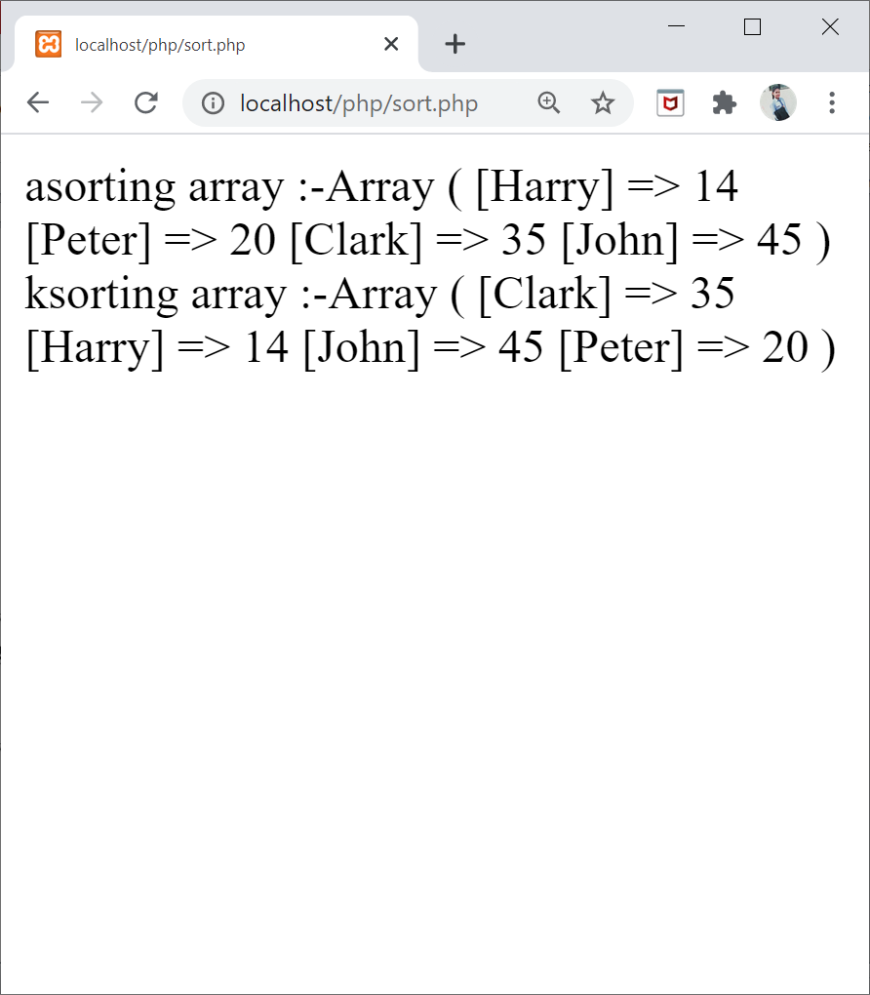

**7. Write an algorithm, draw a flowchart and Write a PHP script to for creating, Retrieving and Deleting data from the cookie using POST Method.**

<?php

setcookie("user", "RCC");

?>

<html>

<body>

<?php

if(!isset($_COOKIE["user"])) {

echo "Sorry, cookie is not found!";

} else {

echo "<br/>Cookie Value: " . $_COOKIE["user"];

}

?>

</body>

</html>

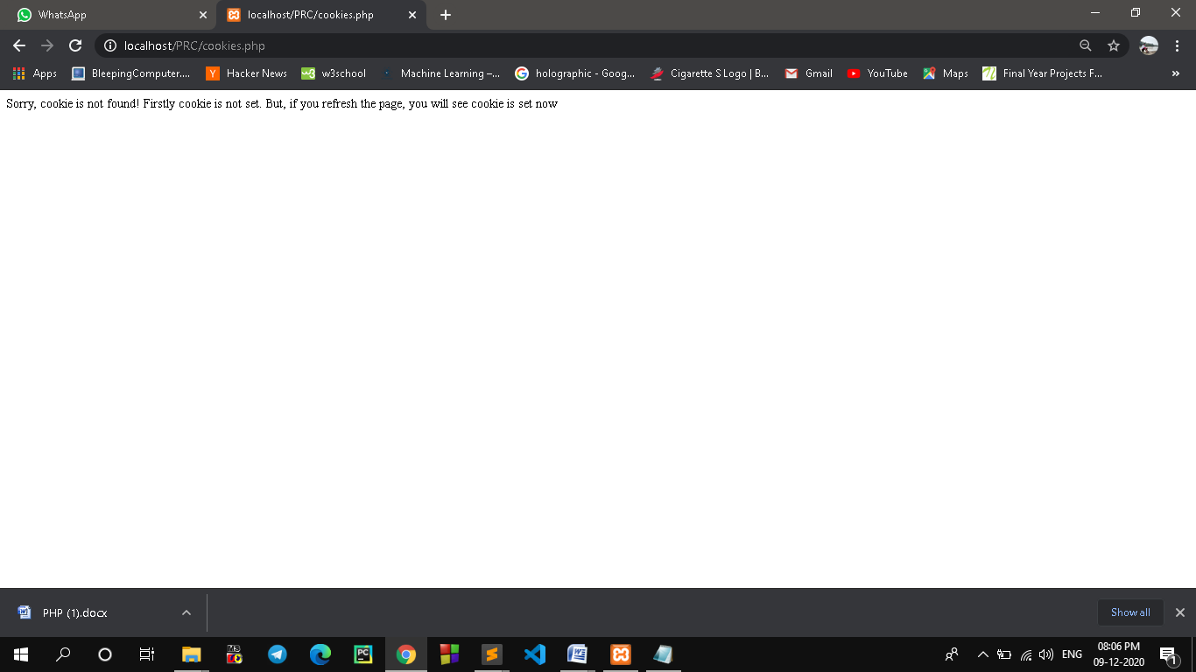

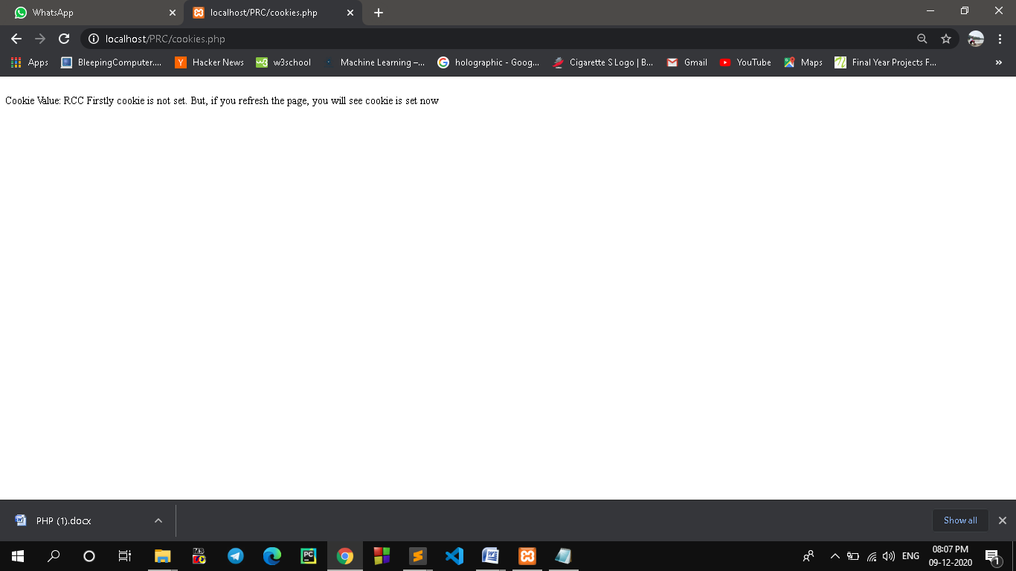

**8. Write an algorithm, draw a flowchart and Write a PHP script to convert a data from yyyy-mm-dd to dd-mm-yyyy. Sample Date: 2000-11-30 Expected Result:30-11-2000.**

<!DOCTYPE html>

<html>

<head>

<title></title>

</head>

<body>

<?php

$odate = "2000-09-30";

$newDate=date("d-m-Y",strtotime($odate));

echo $newDate."\n";

?>

</body>

</html>

**Output:**

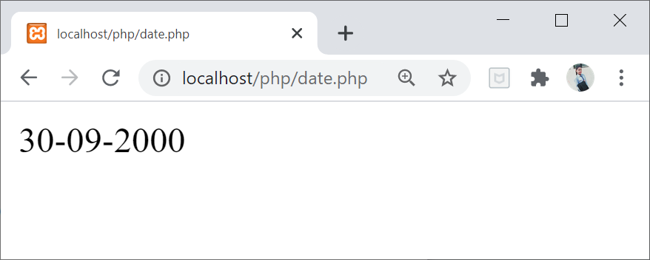

**9. Write an algorithm, draw a flowchart and Write a PHP script to remove the whitespaces from a string.**

<?php

$str = " PHP trim() function to remove whitespace including non-breaking spaces, newlines, and tabs from the beginning and end of the string ";

echo "original string :--<br/>" . $str;

echo "<br/></br/>";

echo "After string :--<br/>" . trim($str);

?>

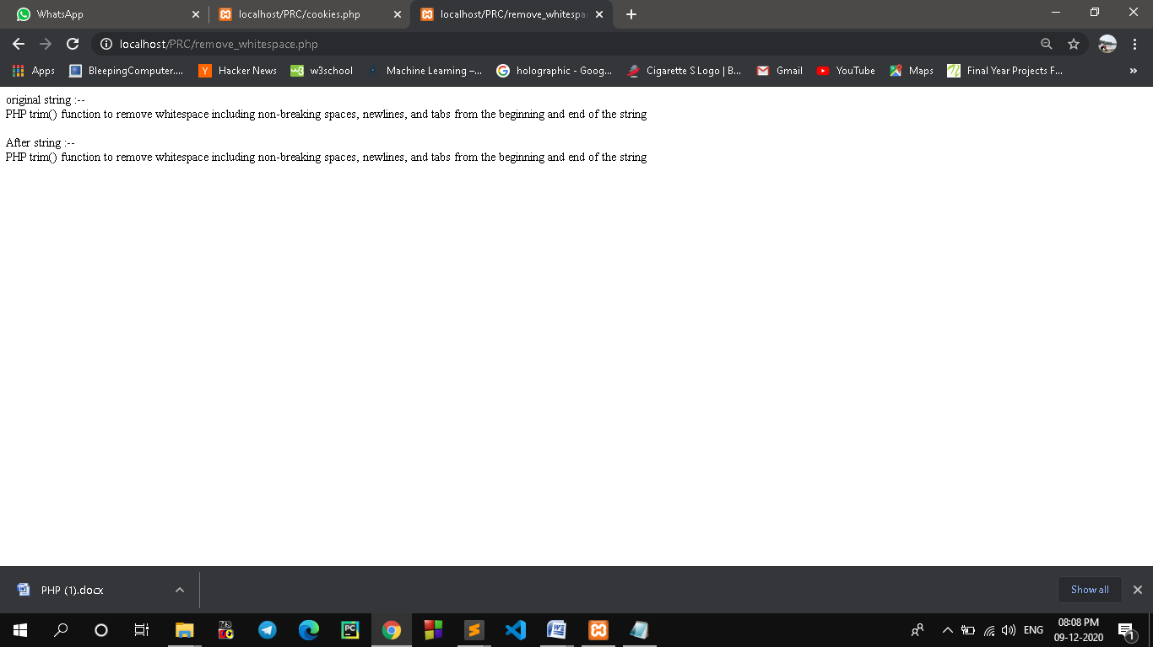

**10. Write an algorithm, draw a flowchart and Write a PHP function that checks if a string is all lower case.**

<!DOCTYPE html>

<html>

<head>

<title></title>

</head>

<body>

<?php

function is_str_lowercase($str1)

{

for ($i = 0; $i< strlen($str1); $i++) {

if (ord($str1[$i]) >= ord('A') &&

ord($str1[$i]) <= ord('Z')) {

return false;

}

}

return true;

}

var_dump(is_str_lowercase('DGJHJIURGR'));

echo"<br>";

var_dump(is_str_lowercase('abcdefghi'));

?>

</body>

</html>

**Output:**

